Sponsorship Prospectus
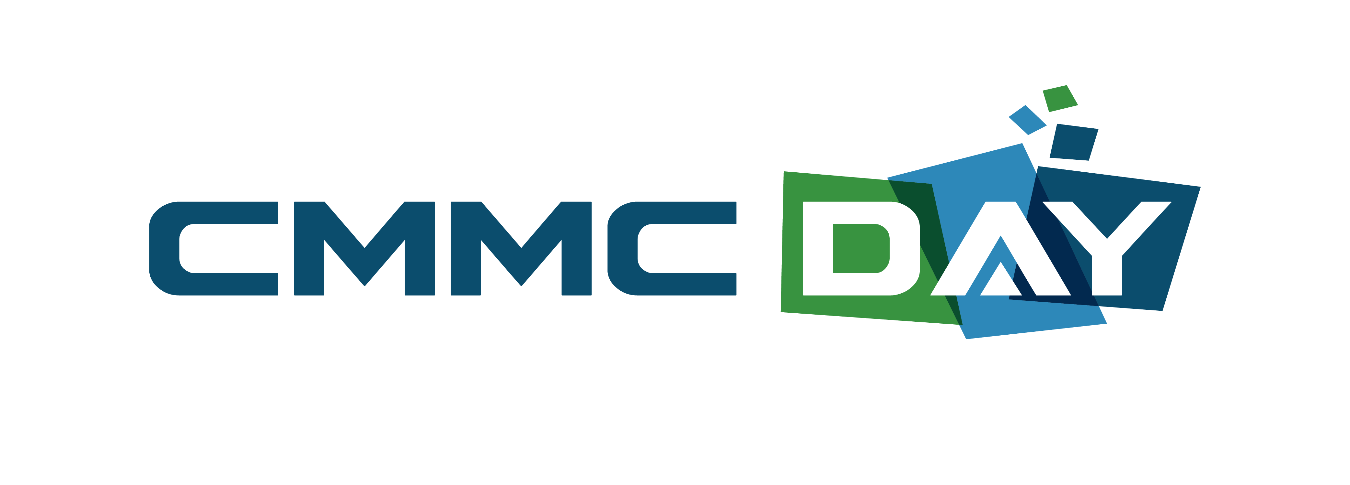
May 9, 2022 • Washington, DC • www.CMMCDay.org
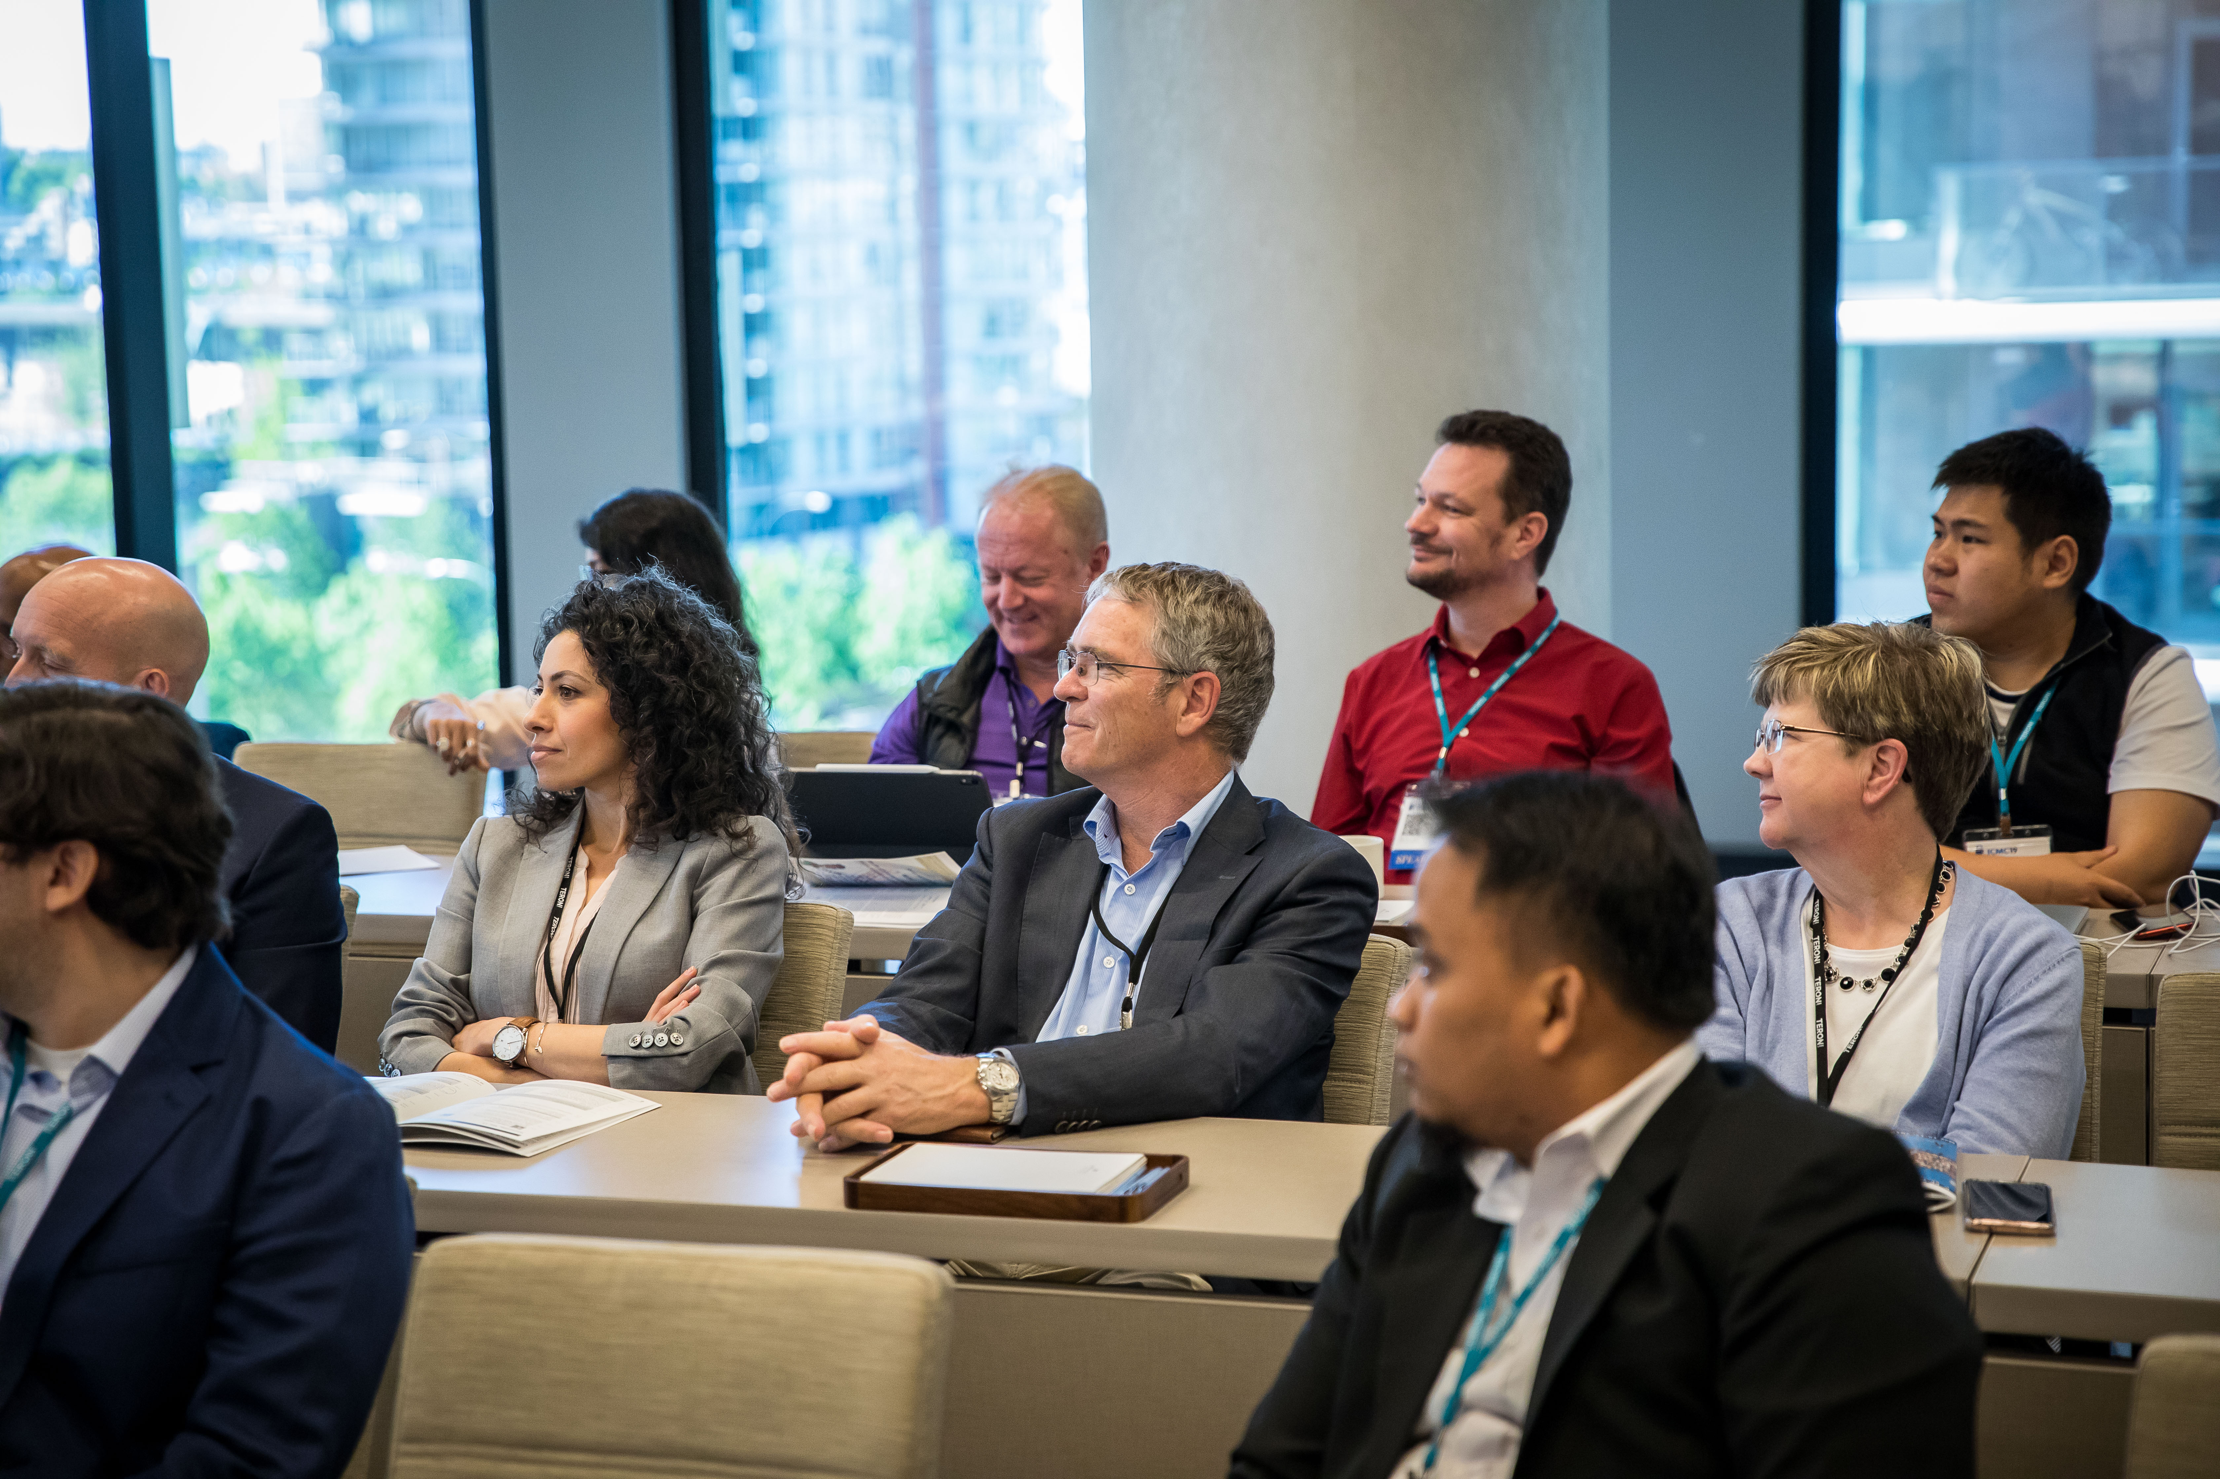  A comprehensive event for CMMC professionals at every level.  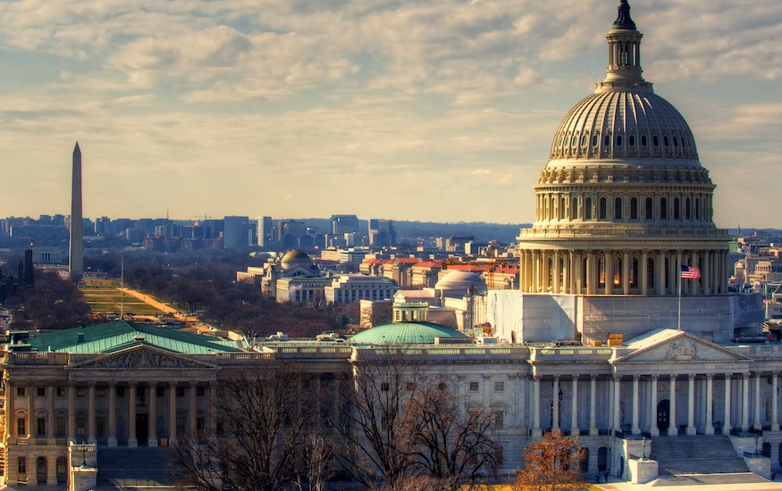  In the Washington DC area, with easy local and national access  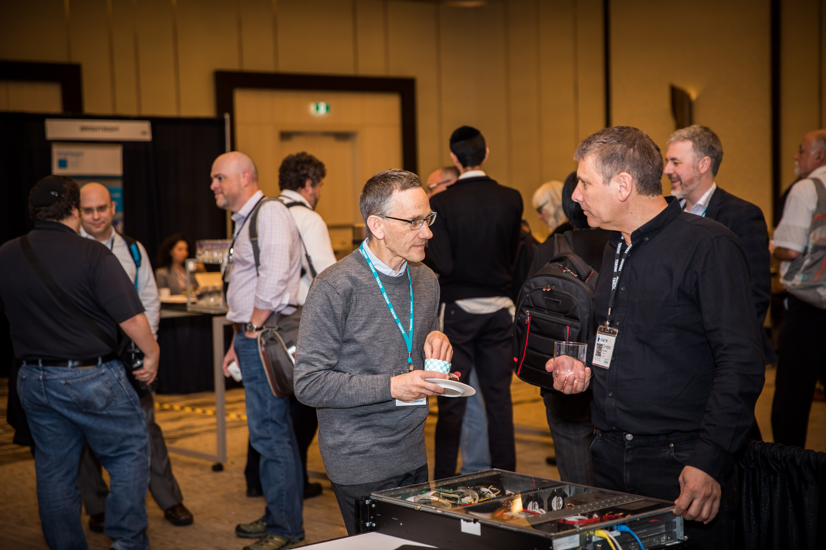  Connect with potential clients during breaks and lunch. | Showcase Your Company at a Forum on New Efforts to Secure the Supply Chain  Over 300,000 US government Defense Industrial Base (DIB) subcontractors will soon be affected by the Cybersecurity Maturity Model Certification (CMMC) framework to secure the federal supply chain. As CMMC rolls out, new certification requirements will apply to commercial product developers, DIB subcontractors, integrators, and testing laboratories.  A Unique Promotion Opportunity  CMMC Day will bring together all these industry stakeholders to review foundational federal supply chain cybersecurity standards and best practices in order to develop strategies for compliance. These stakeholders are attending CMMC Day in search of technologies, solutions, consulting, assessment, and certification that will help them to grapple with these new requirements. It’s a unique opportunity to interact with potential clients in the midst of an important decision-making process.  Extensive Agency Support  CMMC Day receives extensive speaker support from NIST, NIAP, and the NSA—all major players in the rollout of CMMC. The Conference brings together the entire industry value chain: product vendors, component suppliers, commercial testing laboratories, trusted integrators, standards organizations, and government agencies.  A Return to Face to Face Events  This year CMMC Day will return to a fully-live, face-to-face event format. There’s great pent-up demand for a live forum—the survey of previous attendees showed that the vast majority (over 75%) wanted to return to a live event. It’s a perfect opportunity to reconnect with colleagues and network with potential clients.
For additional info, or to reserve, contact Andrew Baranich, Sponsorship Program Manager, andrew@cnxtd.com, +1 501-222-1430
Sponsorship Opportunities  Title Sponsorships  Title Sponsorships put your branding message front and center, next to the title of the conference. Title sponsors receive exclusive branding opportunities prior to, and during the event. Title sponsors may choose from premium sponsor booths, located at the front of the hall.  Platinum Sponsor (Exclusive)  This premium package incorporates “over-conference-title” logo billing and a combination of maximum brand exposure, content input and excellent networking opportunities. Highlights include a welcome address during the plenary presentation and significant branding throughout the conference, including pre- and post-event. Includes:  [PRE-EVENT] Digital: Premium “over-conference-title” logo on all conference registration and web site pages • Lead logo and 150 word description on conference website sponsor page • Link from conference website to your website • Logo on all email collateral Print: Premium “over-conference-title” logo on all relevant hard copy collateral [ON-SITE] Acknowledgement during opening plenary keynote presentation • Opportunity to make a 10 minute welcome address at the opening of the event Branding: Welcome letter in conference materials • Premium “over-conference-title” logo on welcome signage • Opportunity to hang an exclusive banner (up to 8×8 feet) in conference room • Opportunity to hang a banner (up to 8×8 feet) in registration area • Logo on plenary PowerPoint • Logo and 150-word description in conference materials Networking and Exhibition: One premium position exhibit space • Six complimentary delegate passes • Code good for 50% discount for 12 VIP guests • Code good for 20% discount for unlimited VIP guests [POST-EVENT] Lead logo and 150-word description on sponsor page of post-event web site • PowerPoint presentation uploaded on post-event web site  Sponsorship Fee $6700  Gold Sponsor (Limit 2 Sponsors)  Incorporates “under-conference-title” logo billing and a combination of extensive brand exposure and excellent networking opportunities. Includes: |  | [PRE-EVENT] Digital: Premium “under-conference-title” logo on all conference registration and web site pages • Lead logo and 150 word description on conference website sponsor page • Link from conference website to your website • Logo on all email collateral Print: Premium “under-conference title” logo on all relevant hard copy collateral [ON-SITE] Premium “under-conference-title” logo on welcome signage • Opportunity to hang a banner (up to 8×8 feet) in registration area • Logo on plenary PowerPoint • Logo and 150-word description in conference materials • Networking and Exhibition: One premium position exhibit space • Four complimentary delegate passes • Code good for 50% discount for 8 VIP guests • Code good for 20% discount for unlimited VIP guests [POST-EVENT] Logo and 150-word description on sponsor page of post-event web site • PowerPoint presentation uploaded on post-event web site  Sponsorship Fee $4500  Silver Sponsor (Limit 4 Sponsors)  Incorporates “under-conference-title” logo billing and extensive brand exposure and networking opportunities. Includes:  [PRE-EVENT] Digital: Premium “under-conference-title” logo on all conference registration and web site pages • Lead logo and 150-word description on conference website sponsor page • Link from CMMC Day website to your website • Logo on all email collateral Print: Premium “under-conference-title” logo on all relevant hard copy collateral [ON-SITE] Premium “under-conference-title” logo on welcome signage • Logo on plenary PowerPoint • Logo on back cover of CMMC Day Guide • Logo and 150-word description in conference materials Networking and Exhibition: One exhibit space • Three complimentary delegate passes • Code good for 50% discount for 6 VIP guests • Code good for 20% discount for unlimited VIP guests [POST-EVENT] Logo and 150-word description on sponsor page of post-event web site • PowerPoint presentation uploaded on post-event web site  Sponsorship Fee $3200
Exhibition Space  Reserve a booth space in the CMMC Day showcase exhibition. All breaks, lunches, and hospitality events are held in the exhibit hall. Includes: Table-top booth space with 5’ x 30” high table, chair, and company ID sign. • One complimentary conference registration pass ($395 value) • Admission to all conference activities • Inclusion on email, web and collateral—over 325,000 impressions.  Sponsorship Fee $1600  Important Notice: This is a showcase exhibition. Only “pop up” style booths permitted. Display materials limited to what can be brought in by hand. Drayage services not available. Electrical and Internet services can be ordered. Full time staffing of exhibit space not required.  Sponsorship Opportunities  Other Promotional Opportunities  Exclusive Lunch Sponsor  Exclusive sponsor for the conference lunch served to all conference attendees. Includes: Option to offer logo’d cups, glasses and/or napkins (sponsor provides logo’d items) • Sponsor sign in registration area • Table signs • Highlight in conference agenda • One insert into handout materials • One conference pass • Logo on conference website • Inclusion in all conference promo  Sponsorship Fee $1200  Exclusive Conference Break Sponsor  Exclusive sponsor for conference breaks, served in the morning and afternoon of the event. Includes: Option to offer logo’d cups, glasses and/or napkins (sponsor provides logo’d items) • Sponsor sign in registration area • Table signs • Highlight in conference agenda • One insert into handout materials • One conference pass • Logo on conference website • Inclusion in all conference promo  Sponsorship Fee $1200 |  | Event Sponsor  Take advantage of a discount package of our most popular branding opportunities. Includes: Sponsor sign in registration area • One conference pass • One insert into handout materials • 1/4 page b/w ad or sponsor message in the program guide • Logo on conference web site • Inclusion in all conference promo  Sponsorship Fee $900  Conference Bag insertion Advertising  All conference attendees receive an official welcome packet of conference materials. Includes: One insert into handout materials placed in packet.  Sponsorship Fee $500  Hanging Banner  Banner (sponsor provides, up to 8×8 feet) to be hung in conference registration area.  Sponsorship Fee $500

